<https://github.com/gautamtata/DeepPlastic/blob/master/README.md>

in this GitHub I found robotic approach to finding plastic bags under and on surfaces of water using deep learning. it was done by using data construction which was made of data collecting videos of marine plastic bags around Californian shores. The videos have variety in their quality, depth, and visibility to represent differences in marine environments.

Due to the difficulty of identifying different objects due to nature of illumination, occlusion and noise effecting the image processing. the group used very complex algorithm for data augmentation to mitigate the effect of the things mentioned above.

<https://iopscience.iop.org/article/10.1088/1748-9326/abbd01>

here is example of similar project done with satellite image detection. However this is far more extensive since it is more used to detect mass amount of litter not just plastic in the ocean . however it still uses image processing for this method . (2)

<https://www.section.io/engineering-education/introduction-to-yolo-algorithm-for-object-detection/>

this article talks about the YOLO algothrim to object detection works and we find that it consist of 3 types of techniques.

Residual blocks

image is divided into various grids. Each grid has a dimension of S x S. the image below shows how the grids work.

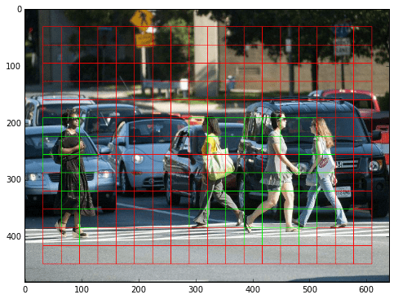

Bounding box regression

A bounding box highlights a object of interest in the image.

Boxes contain the following attributes.

Width (bw)

Height (bh)

Class (for example, person, car, traffic light, etc.)- repesneted by c.

And lastly Bounding box center (bx,by)

Look at the image below to see how it works.

Intersection over union (IOU)

IOU is a is a technique used for object detection that describes how boxes overlap. YOLO uses IOU to provide an output box that surrounds the objects accurately.

Each grid cell is responsible for predicting the bounding boxes and their confidence scores. The IOU is equal to 1 if the predicted bounding box is the same as the real box. This mechanism eliminates bounding boxes that are not equal to the real box.

And then when you combine all the images you get the following

(3)

# Alternative to YOLO : Haar Classifier

Haar classifier, or a Haar cascade classifier, is a type of objection detection program similar to YOLO that can process objects in an image and video. The algorithm of this object detector have 4 stages:

Calculating Haar Features

Creating Integral Images

Using Adaboost

Implementing Cascading Classifiers

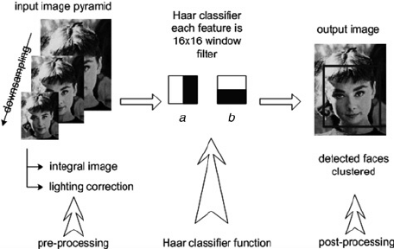

# Bibliography

Tata, G., Lowe, J., Poirion, O. and Royerc, S., 2021. *A Robotic Approach towards Quantifying Epipelagic Bound Plastic Using Deep Visual Models*. [online] Arxiv.org. Available at: <https://arxiv.org/pdf/2105.01882.pdf> [Accessed 18 October 2021].

**:**Iopscience.iop.org. 2021. *Machine learning for aquatic plastic litter detection, classification and quantification (APLASTIC-Q)*. [online] Available at: <https://iopscience.iop.org/article/10.1088/1748-9326/abbd01> [Accessed 17 October 2021]. (2)

Karimi, G., 2021. *Introduction to YOLO Algorithm for Object Detection*. [online] Engineering Education (EngEd) Program | Section. Available at: <https://www.section.io/engineering-education/introduction-to-yolo-algorithm-for-object-detection/#:~:text=YOLO%20is%20an%20abbreviation%20for,probabilities%20of%20the%20detected%20images.> [Accessed 23 October 2021](3)

Mittal, A., 2021. *Haar Cascades, Explained*. [online] Medium. Available at: <https://medium.com/analytics-vidhya/haar-cascades-explained-38210e57970d> [Accessed 17 November 2021].(4)

P. Viola and M. Jones, "Rapid object detection using a boosted cascade of simple features," Proceedings of the 2001 IEEE Computer Society Conference on Computer Vision and Pattern Recognition. CVPR 2001, 2001, pp. I-I, doi: 10.1109/CVPR.2001.990517.(5)

Lebreton, L., Slat, B., Ferrari, F. *et al.* Evidence that the Great Pacific Garbage Patch is rapidly accumulating plastic. *Sci Rep* **8,**4666 (2018). https://doi.org/10.1038/s41598-018-22939-w(6)